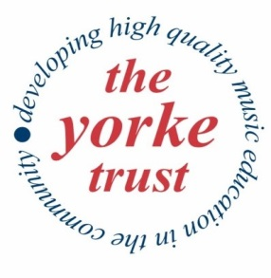
Why do we need your help?
Our aim at the Yorke Trust is to provide opportunities for students and children from all walks of life to study and to perform in the un-pressurised atmosphere of the North Norfolk countryside, away from the competitive environment of university and school. We have been doing this since 1984 and we have been doing it virtually free of charge.
Our work began with the Yorke Mini-Bass Project, an innovative scheme to enable children to play the double bass. Acquisition of premises in Norfolk enabled us to broaden our horizons and focus on singing as well as providing facilities for instrumental courses and workshops for students. Trustees invite you to join them in helping to continue this valuable work in the years ahead.
What can you do?
By becoming a Friend of The Yorke Trust, you join a group of supporters whose generosity provides a regular income to help us fulfil our aims.
Your valuable support can be given by cheque, a bank transfer or by setting up a standing order with your bank.
Please return to:-
Friars Acre, Friars Lane, Burnham Norton,
King’s Lynn, PE31 8JA

The Yorke Trust is a Charitable Incorporated Organistation No 1158927

Application for Friends Membership

The annual subscription is at least £30 for an Individual Member and £45 for Joint Members (two individuals). Membership runs for one year from 1st January.

Friends of The Yorke Trust receive 10% reduction on all tickets and their names will appear in each programme unless advised otherwise.

(Please tick as appropriate)
Individual Member □ Joint Membership □

Title:……. Name:……………………………………………………

Address:…………………………………………………………..….
.………………………………………………………………………..
Postcode:………………………………………………………..……
Telephone:……………………………………………………………
Email ………………………………………………………………....

I enclose remittance for £…………………………………
Cheques: Payable to The Yorke Trust
BACs: Sort code: 52 41 29 A/c 44630417

I want to Gift Aid my Membership Subscription to The Yorke Trust. I am a UK taxpayer and understand that if I pay less Income Tax and/or capital Gains Tax than the amount of Gift Aid claimed on all my donations in that tax year, it is my responsibility to pay any difference.

Signed…………………………………………………………..

